| **Project Title** | | | Recipe Recommendation Based On Ingredients  Recognition Using CV AND ML | | | |
| --- | --- | --- | --- | --- | --- | --- |
| **Batch No** | | | 14 | | | |
| **Week Starting Date** | | | 18-04-2022 | **Week Ending Date** | | 24-04-2022 |
| **Name** | | | A R Manyatha  Amulya S Dinesh  Manasi Swain  Mihir Soni | **SRN** | | PES2UG19CS002  PES2UG19CS035  PES2UG19CS216  PES2UG19CS232 |
| **Activities Completed** | | | | | | |
| **#** | | **Tasks** | | **Date** | **Remarks** | |
| 1 | | High Level Documentation | | 18-04-2022 |  | |
| 2 | | Review 3 PPT | | 22-04-2022 |  | |
| 3 | |  | |  |  | |
| **In Progress** | | | | | | |
| **#** | **Tasks** | | | **Date** | **Remarks** | |
| 1 | Review 3 Preparation | | | 24-04-2022 |  | |
| 2 |  | | |  |  | |
| **Plan for Next Week** | | | | | | |
| **#** | | **Tasks** | | **Date** | **Remarks** | |
| 1 | | Complete Documentation for phase 1(ESA) | | 27-04-2022 |  | |
| 2 | |  | |  |  | |

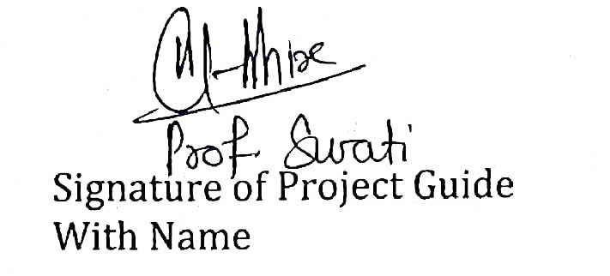

| Signature of Project Guide  With Name | Signature of Project Coordinator | Signature of Chairperson |
| --- | --- | --- |